Inversion of Control:

Outsource to an object factory

The Approach of outsourcing the construction and management of objects.

Apps builds are easily configurable.

Code Demo :

My App.java : Main Menthos

BaseballCoach.Java: Simple Implementation

Coach.java : Interface for refractoring

TrackCoach.java : Other Implementation.

Code to an interface:

**Object Container:**

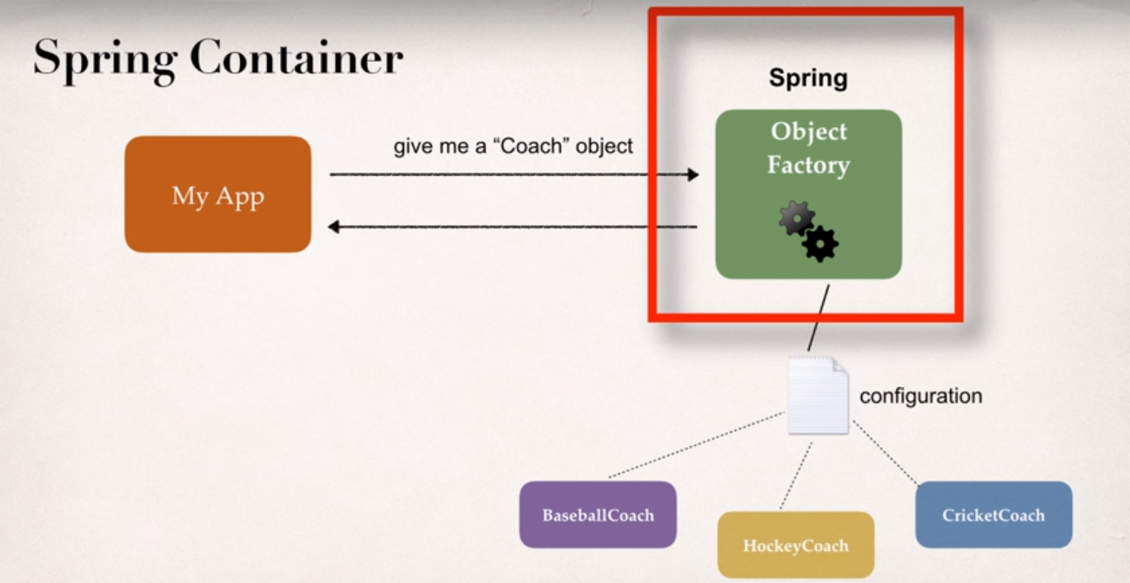

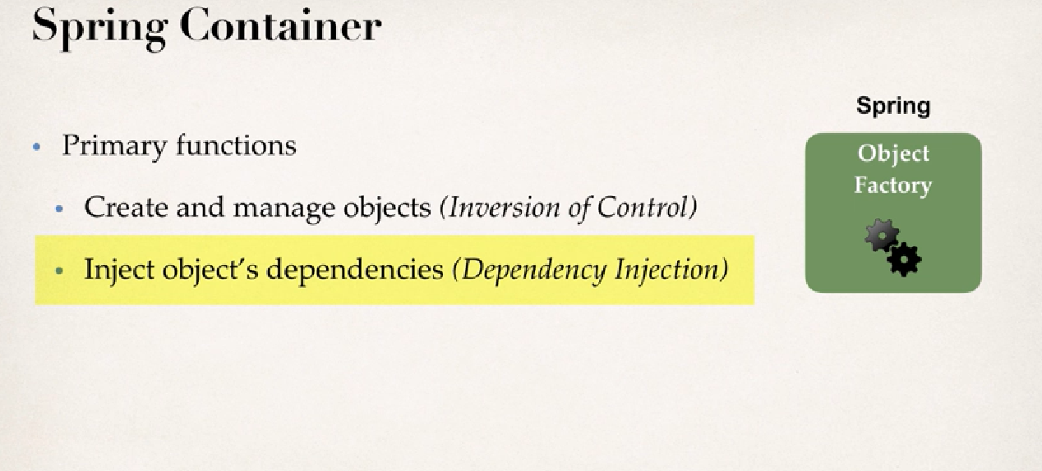

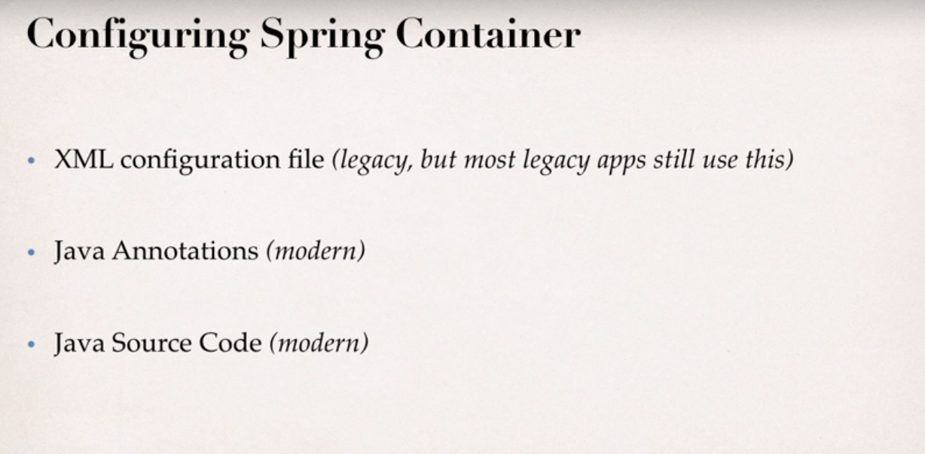

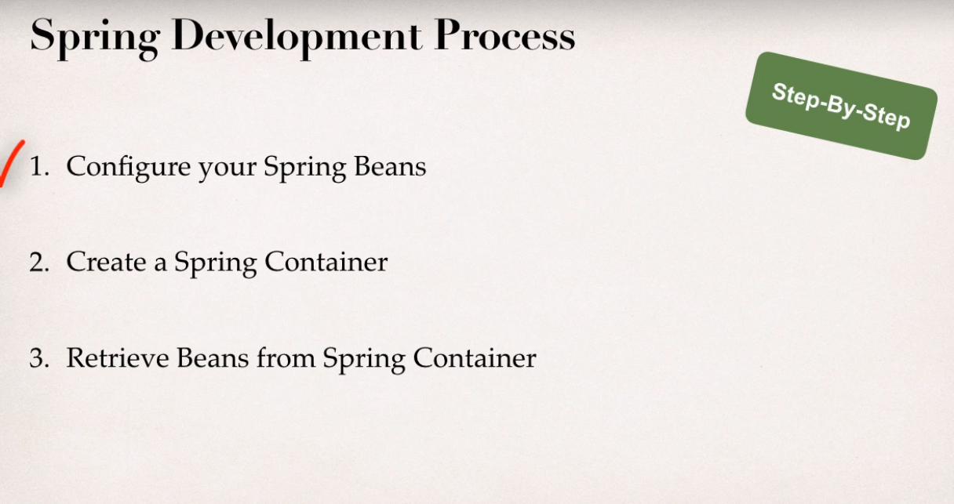

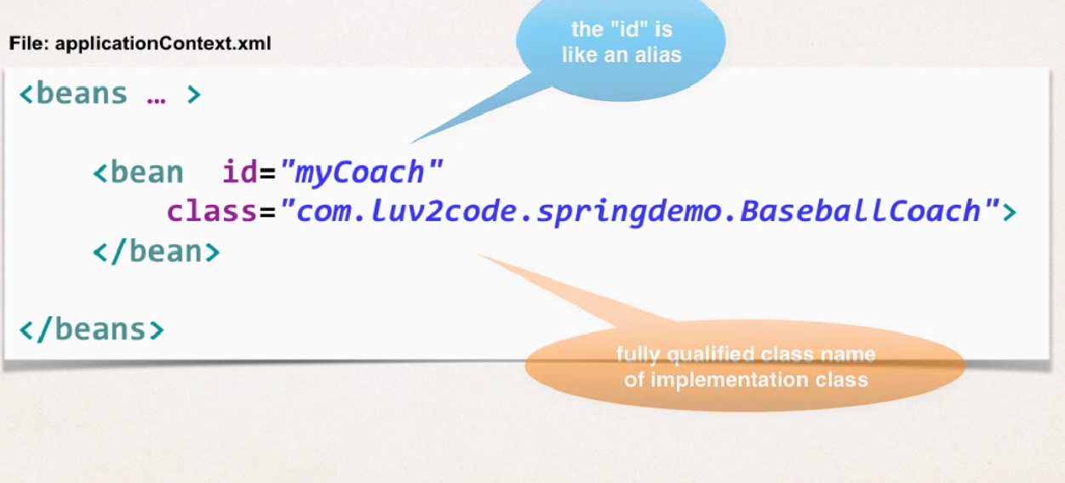

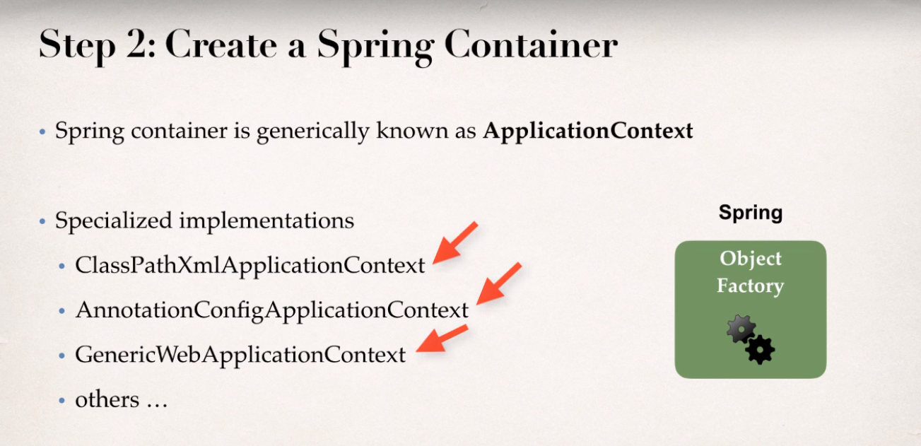

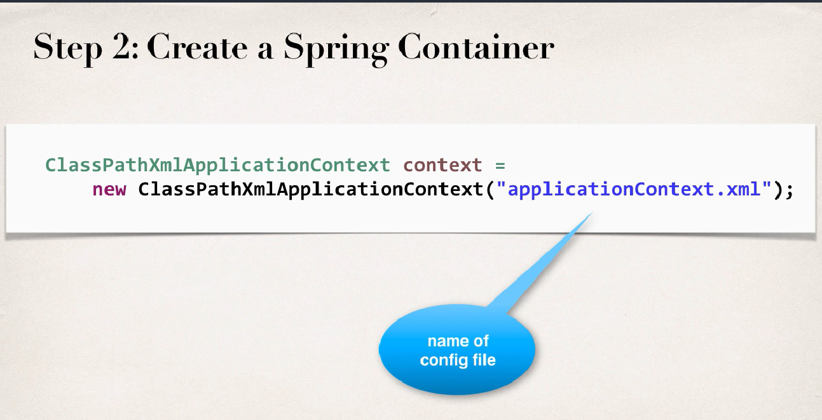

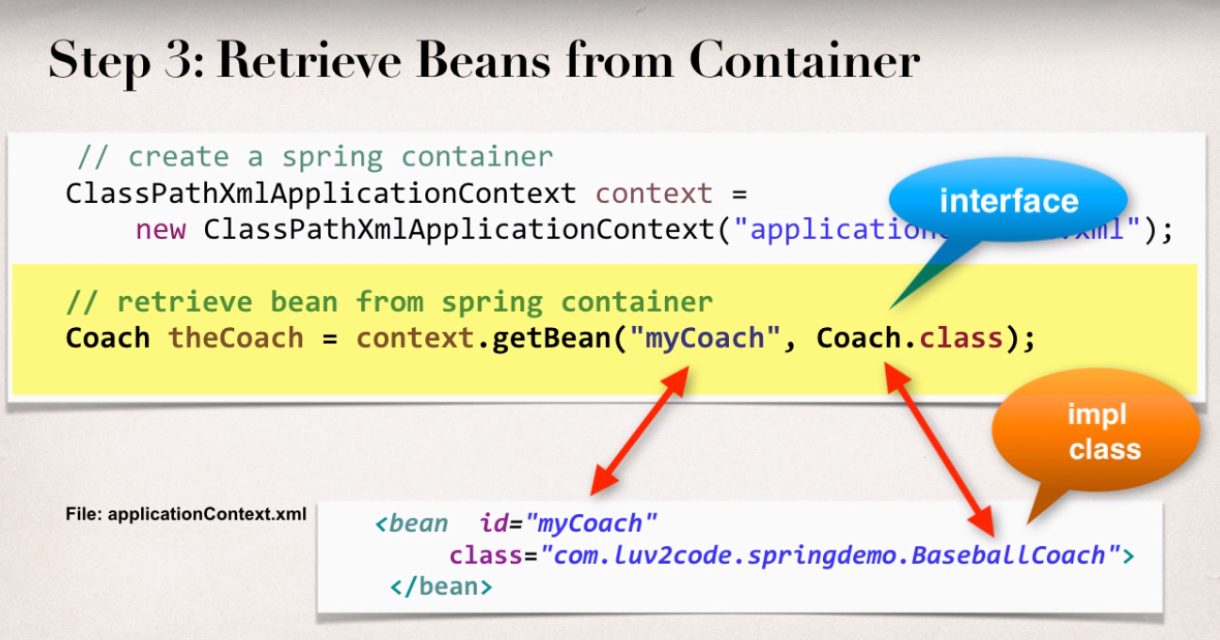

**What is a Spring bean?**

A "Spring Bean" is simply a Java object.

When Java objects are created by the Spring Container, then Spring refers to them as "Spring Beans".

Spring Beans are created from normal Java classes .... just like Java objects.

Why do we specify the Coach interface in getBean()?

For example:

Coach theCoach = context.getBean("myCoach", Coach.class);

When we pass the interface to the method, behind the scenes Spring will cast the object for you.

**From the Spring docs:**

*Behaves the same as getBean(String), but provides a measure of type safety by throwing a BeanNotOfRequiredTypeException if the bean is not of the required type. This means that ClassCastException can't be thrown on casting the result correctly, as can happen with getBean(String).*

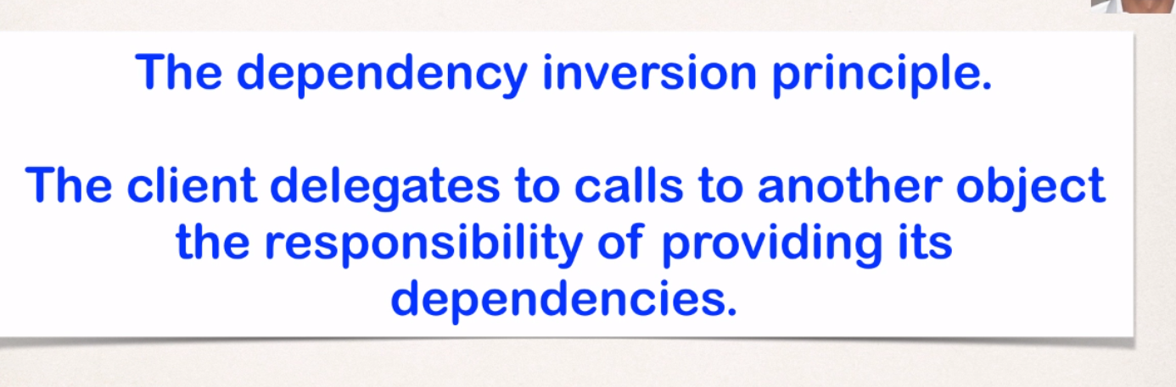

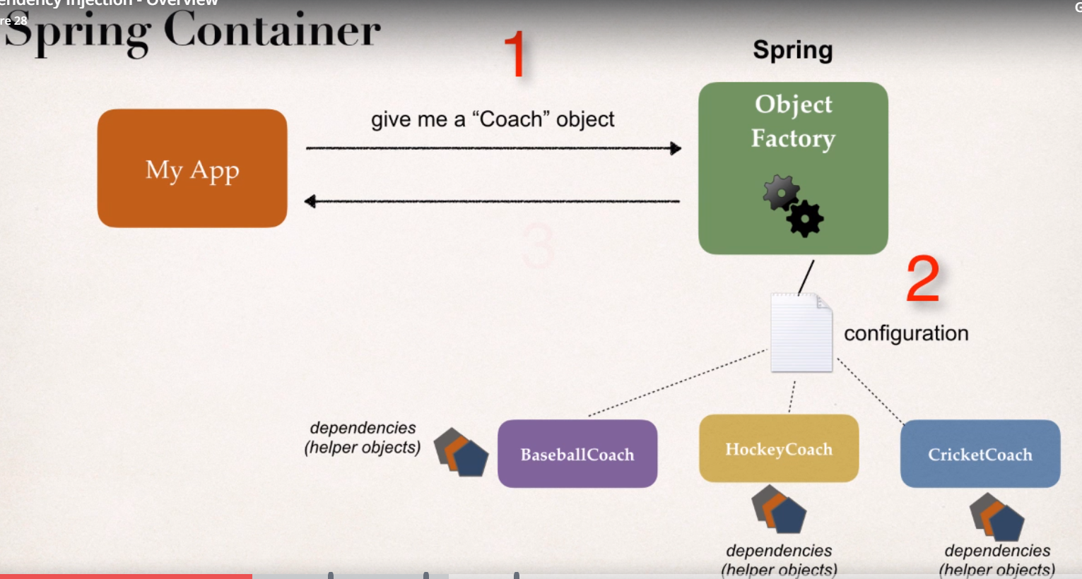

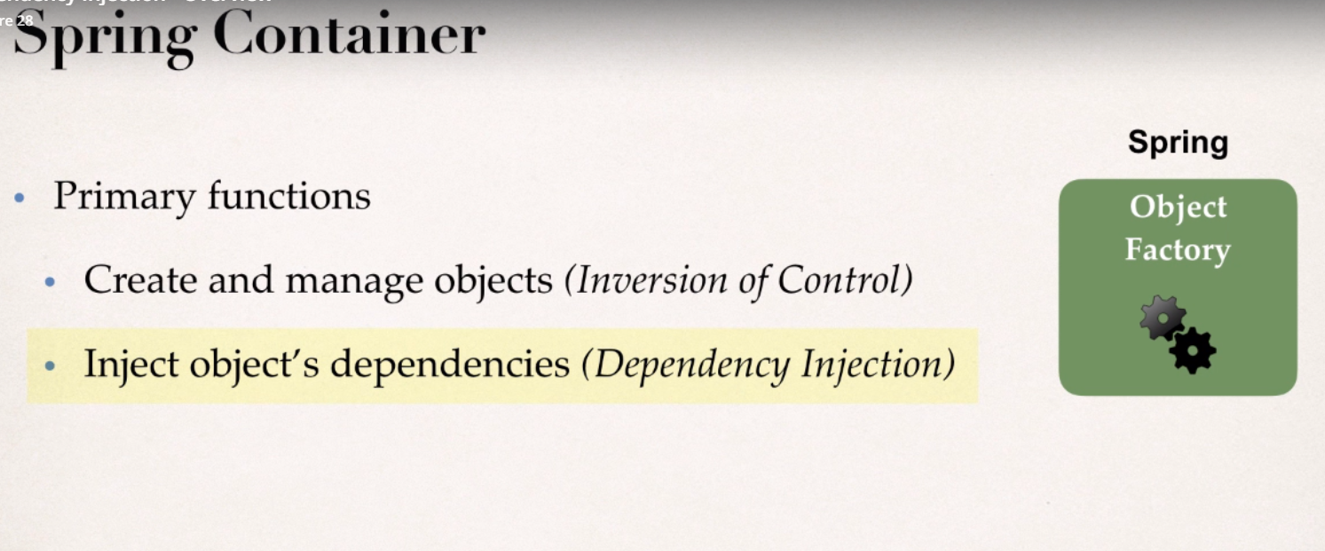

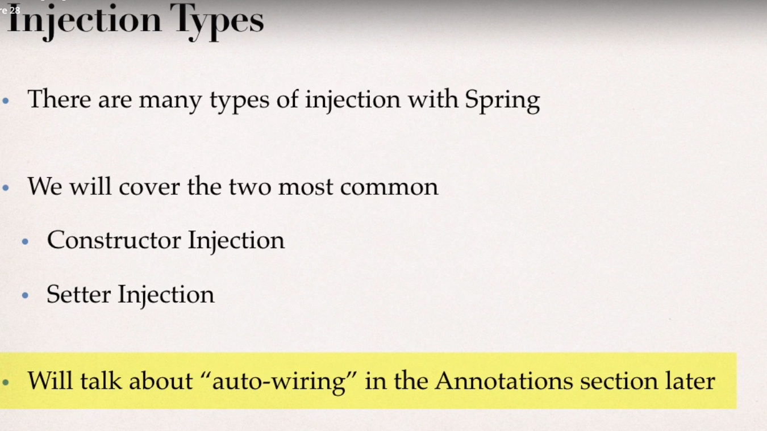

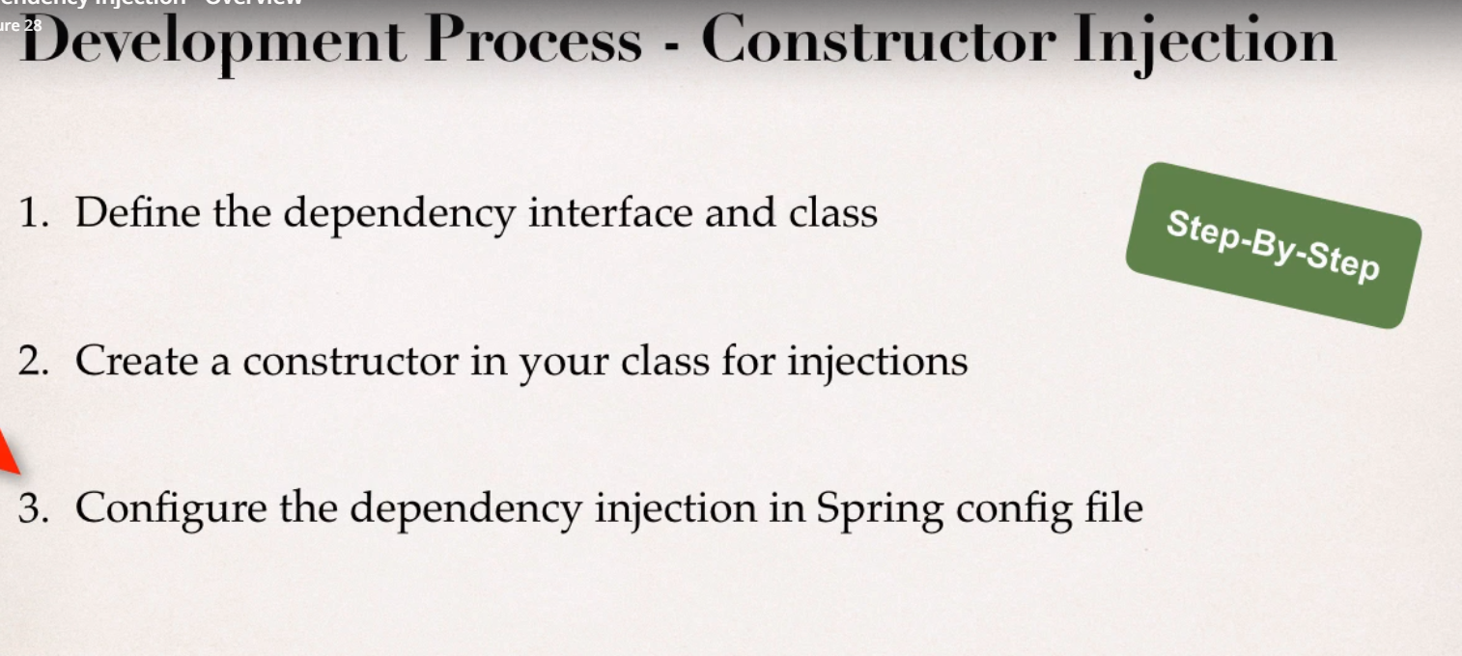

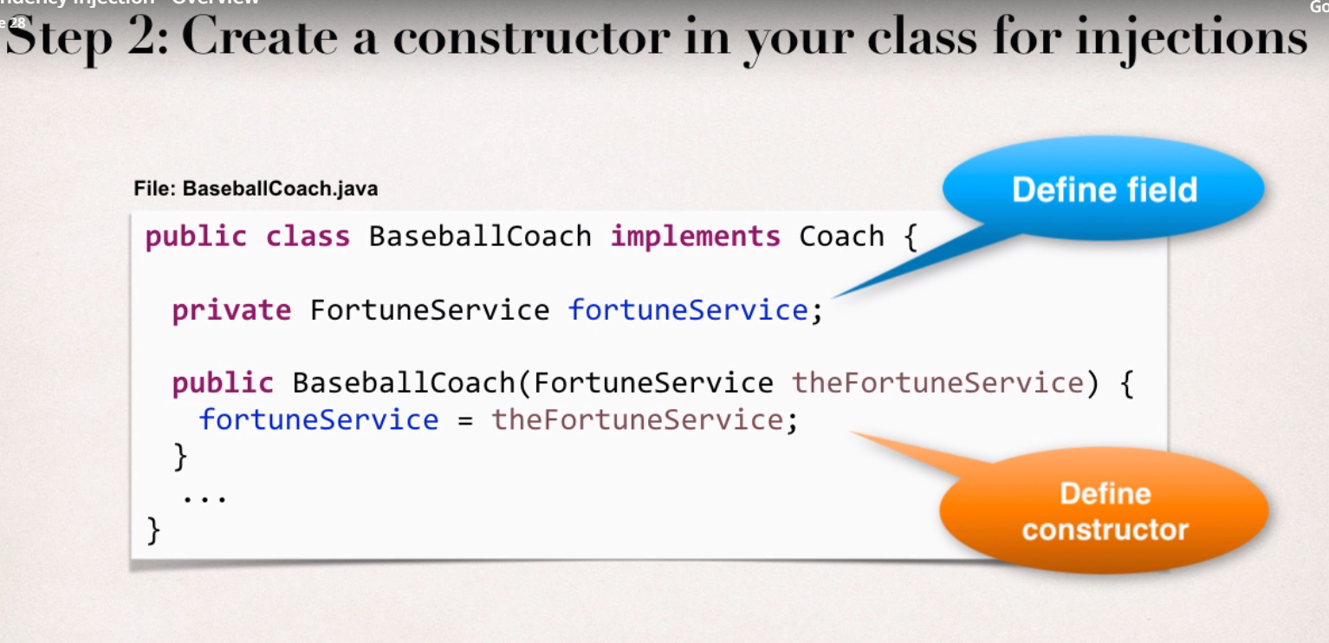

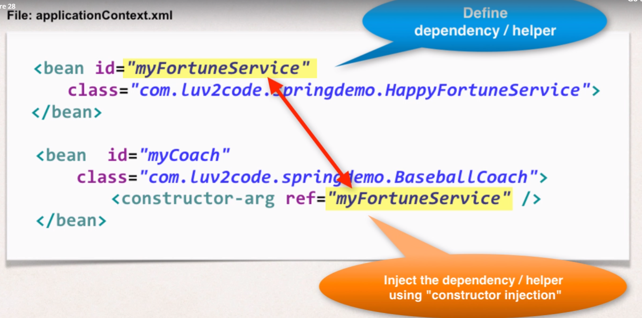

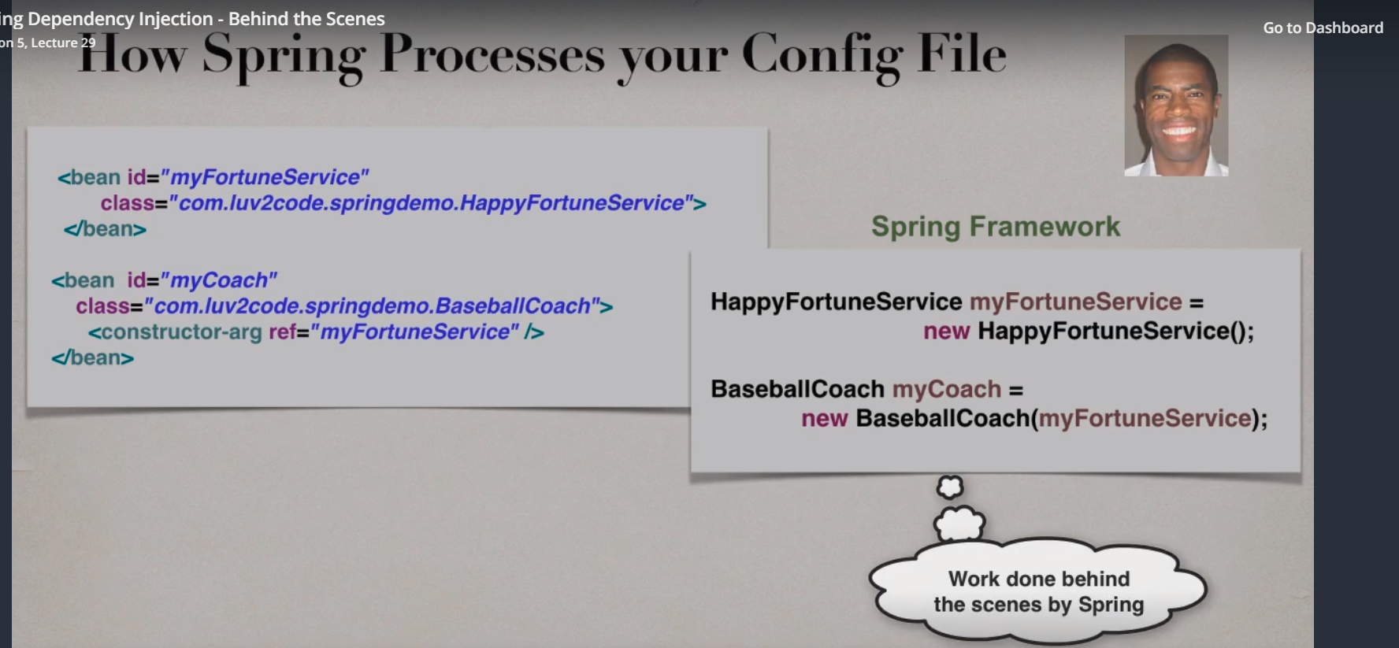

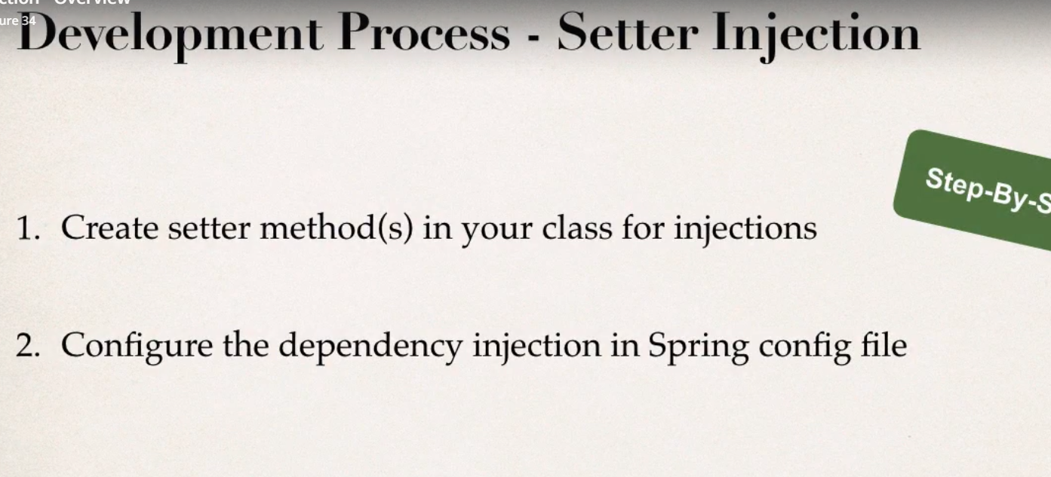

Injecting Literal Values:

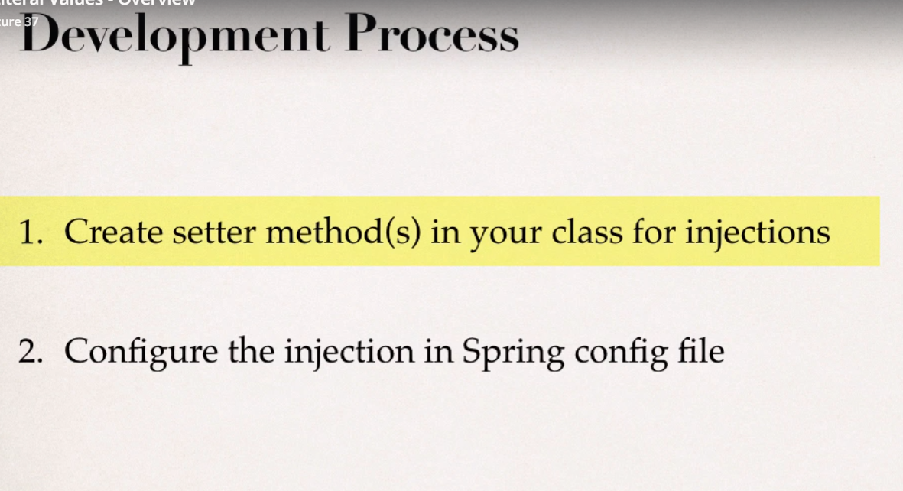

Injecting values from a property file:

